39.45: a) Since 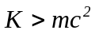 we must use the relativistic expression for energy.

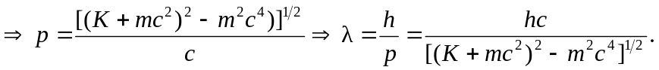
If 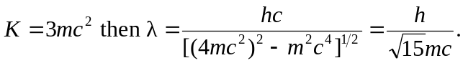
b) i)
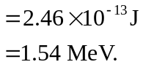
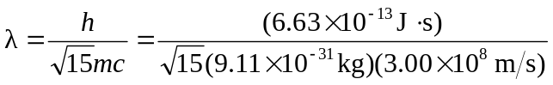
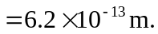
ii)
